EX5 – DAY TIME SERVER USING UDP
- S. Vishakan CSE – C 18 5001 196

Server Program:

#include <stdio.h>
#include <string.h>
#include <string.h>
#include <stdlib.h>
#include <time.h>
#include <sys/socket.h>
#include <netinet/in.h>
#define PORT 7228

int main(int argc, char **argv){
time_t cur_time;
struct sockaddr_in serv_addr, cli_addr;
int sockfd, n, addrlen;
sockfd = socket(AF_INET, SOCK_DGRAM, 0);

if(sockfd < 0){
perror("Error in opening socket.\n");
exit(1);
}

bzero(&serv_addr, sizeof(serv_addr));
serv_addr.sin_family = AF_INET;
serv_addr.sin_addr.s_addr = INADDR_ANY;
serv_addr.sin_port = htons(PORT);

if(bind(sockfd, (struct sockaddr*)&serv_addr, sizeof(serv_addr)) < 0){
//Binding the socket to the port with serv_addr
perror("Bind error occurred.\n");
exit(1);
}

printf("Server awaiting clients on port %d...\n", PORT);
addrlen = sizeof(cli_addr);
while(1){ //server is always up
recvfrom(sockfd, &n, sizeof(n), 0, (struct sockaddr*)&cli_addr, &addrlen);
cur_time = time(NULL);
printf("\nClient %d sent a request through port %d.\n", n, PORT);
sendto(sockfd, &cur_time, sizeof(cur_time), 0, (struct sockaddr*)&cli_addr, addrlen);
printf("Sent current time: %s", ctime(&cur_time));
}
return 0;
}
Output:

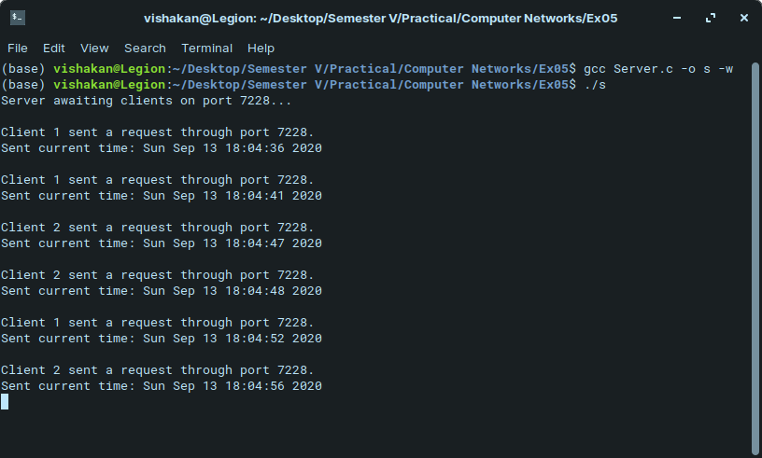
Client Program:

#include <stdio.h>
#include <string.h>
#include <string.h>
#include <stdlib.h>
#include <time.h>
#include <sys/socket.h>
#include <netinet/in.h>

#define PORT 7228

void printOption(time_t cur_time, int opt);

int main(int argc, char **argv){
time_t cur_time;
struct sockaddr_in serv_addr, cli_addr;
int sockfd, n, addrlen, opt, cont;
n = atoi(argv[1]);

sockfd = socket(AF_INET, SOCK_DGRAM, 0);

if(sockfd < 0){
perror("Error in opening socket.\n");
exit(1);
}

bzero(&serv_addr, sizeof(serv_addr));
serv_addr.sin_family = AF_INET;
serv_addr.sin_addr.s_addr = INADDR_ANY;
serv_addr.sin_port = htons(PORT);

addrlen = sizeof(serv_addr);

while(1){
printf("\nRequest to Server:\n\t1 - Date\n\t2 - Day\n\t3 - Month\n\t4 - Year\n\t5 - Time\n\t6 - Toronto Time\nYour Option -> ");

scanf("%d", &opt);
printf("Requesting information to server via port %d.\n\n", PORT);
sendto(sockfd, &n, sizeof(n), 0, (struct sockaddr*)&serv_addr, sizeof(serv_addr));

recvfrom(sockfd, &cur_time, sizeof(cur_time), 0, (struct sockaddr*)&serv_addr, &addrlen);

printOption(cur_time, opt);
printf("\nDo you wish to continue? (0/1) -> ");
scanf("%d", &cont);

if(cont == 0){
break;
}
}

close(sockfd); //close client sockfd once requests are over.

return 0;
}

void printOption(time_t cur_time, int opt){
struct tm *temp;
time_t toronto_time;
char time_buffer[1000];

temp = localtime(&cur_time);

switch(opt){
case 1:
strftime(time_buffer, sizeof(time_buffer), "%x", temp);
printf("Date: %s\n", time_buffer);
break;

case 2:
strftime(time_buffer, sizeof(time_buffer), "%A", temp);
printf("Day of Week\t:\t%s\n", time_buffer);
strftime(time_buffer, sizeof(time_buffer), "%d", temp);
printf("Day of Month\t:\t%s\n", time_buffer);
bzero(&time_buffer, sizeof(time_buffer));
strftime(time_buffer, sizeof(time_buffer), "%j", temp);
printf("Day of Year\t:\t%s\n", time_buffer);
break;

case 3:
strftime(time_buffer, sizeof(time_buffer), "%B", temp);
printf("Month\t:\t%s\n", time_buffer);
break;

case 4:
printf("Year\t:\t%d\n", (temp->tm_year + 1900)); //tm_year stores years elapsed since Unix epoch
break;

case 5:
strftime(time_buffer, sizeof(time_buffer), "%I:%M%p", temp);
printf("Time\t:\t%s\n", time_buffer);
break;

case 6:
strftime(time_buffer, sizeof(time_buffer), "%c", temp);
printf("Local Time\t:\t%s\n", time_buffer);
bzero(&time_buffer, sizeof(time_buffer));
temp = gmtime(&cur_time); //GMT
temp->tm_hour -= 5; //Toronto is -5H ahead of GMT
//temp->tm_min -= 30;
toronto_time = mktime(temp); //Converting the date & time appropriately
temp = localtime(&toronto_time);
strftime(time_buffer, sizeof(time_buffer), "%c", temp);
printf("Toronto Time\t:\t%s\n", time_buffer);
break;

default:
printf("\n\tInvalid option.\n");
break;
}

}

Output:

